GIT-RBT

1)Devops-when we develop software &

Vcs-version ctrl system

Source code management-scm

Container-env details of qa,dev

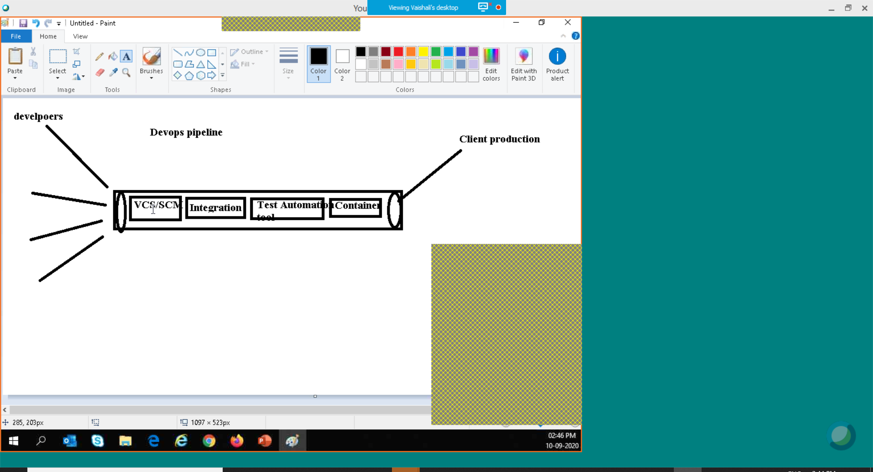

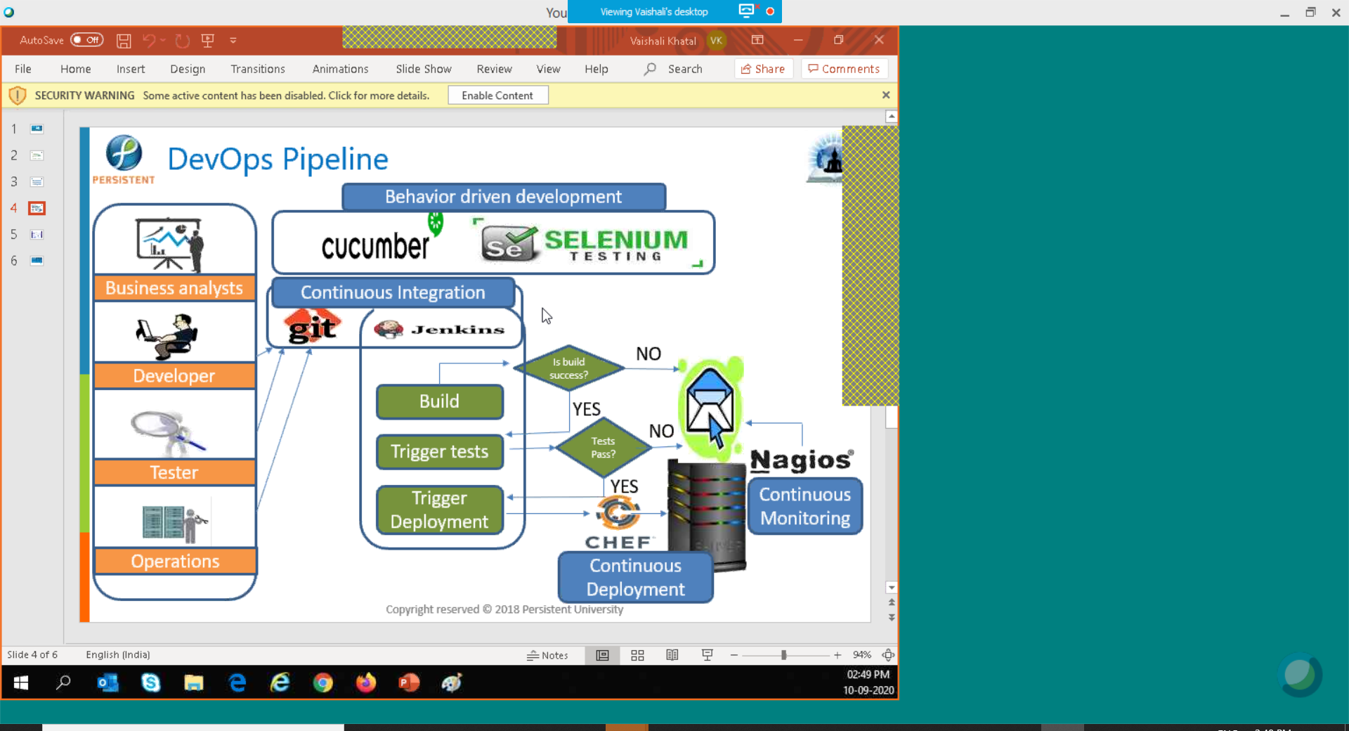

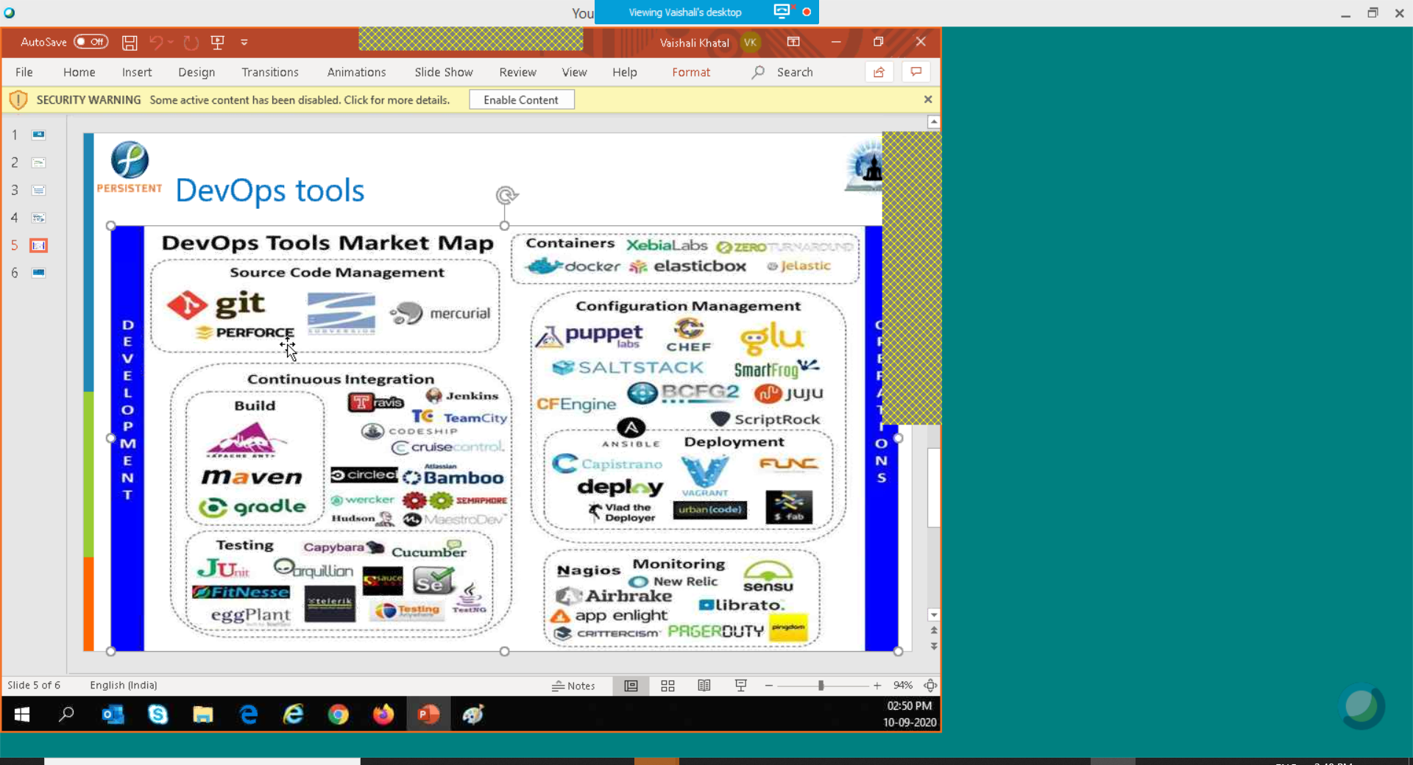

Central repository

Distributed repository

Git is distributed version ctrl system,Direct mgmt. system,studit content tracker

Limitationof centralized

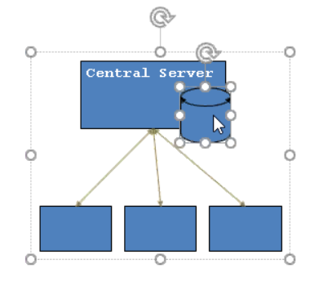

Here if server is down everyone sit idle so we should have code backup

We cant work on same file-no parallel development

We need internet connectivity to connect server

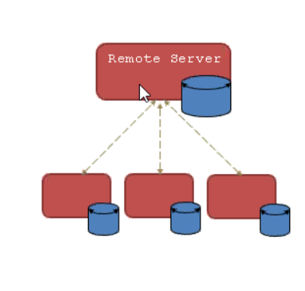

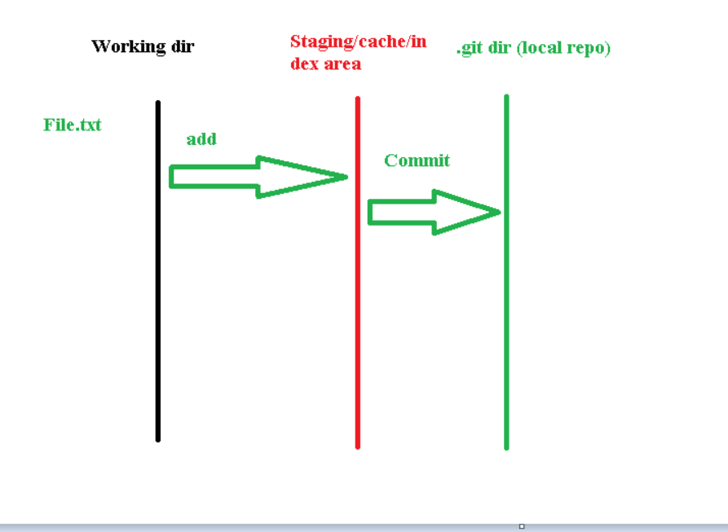

Two mandatory configuration

>>set username

>>mail

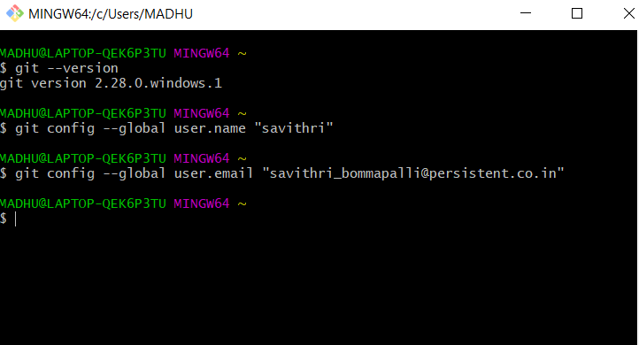

Here no successful msg shown as we have created mail & uname

>>to edit files we should set editor as notepad++ or notepad

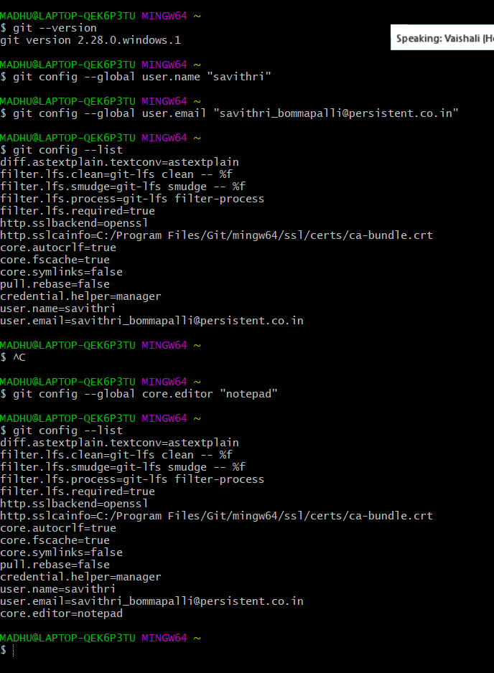

Master points to recent checkin

Head points to all

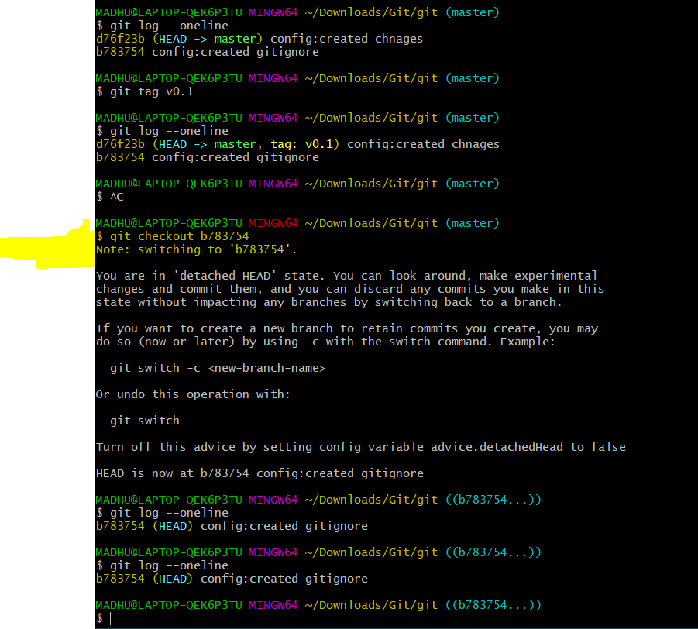

Head is moved to other B783754

Checkout-switch btw branches/tags/versions

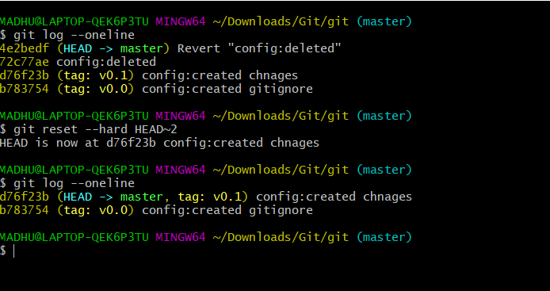

Git commands

|  |
| --- |
| git initt  sl master should come  git status  git add File.txtg  git add .  greencolor-garea added  $ git commit -m "workitem1: File created with hello world"  git log --one line(single user)  git log ---author ="savithri"(multiple)  git log ---author ="savithri" --oneline  ----------  Recent commits-Most recent commits for below  $ git log -2  -----------  below items filter based on string  $ git log --grep="WIT1"  -----------  filter with date,If we mention since results will be comme after the give date  $ git log --since="MMDDYYY 09102020"  $ git log --since="MMDDYYY 09092020"  ---------------  $ git log --untill="MMDDYYY 091002020"  -------------  to help for commands  git log --help  git add -A (--all) Adds everything, so that everything in your folder on disk is represented in the staging area  git add . Stages everything, but does not remove files that have been deleted from the disk  git add * Stages everything, but not files that begin with a dot & does not remove files that have been deleted from the disk  git log checkout  $ git tag v0.1  $ git rm File1.txt --to delete  to revert back file  git revert commit id  undo-  checkout/restore-used in public/private also.undo uncommited/unstagged changes,commit level/fiel level  revert-safe undo commited,commit level(original log recovered-history mintained),pub;ic & private  reset-unsafe undo commited/file level,private/local  commit level-commit id we have to give ex:b784322.. |

Second day-2

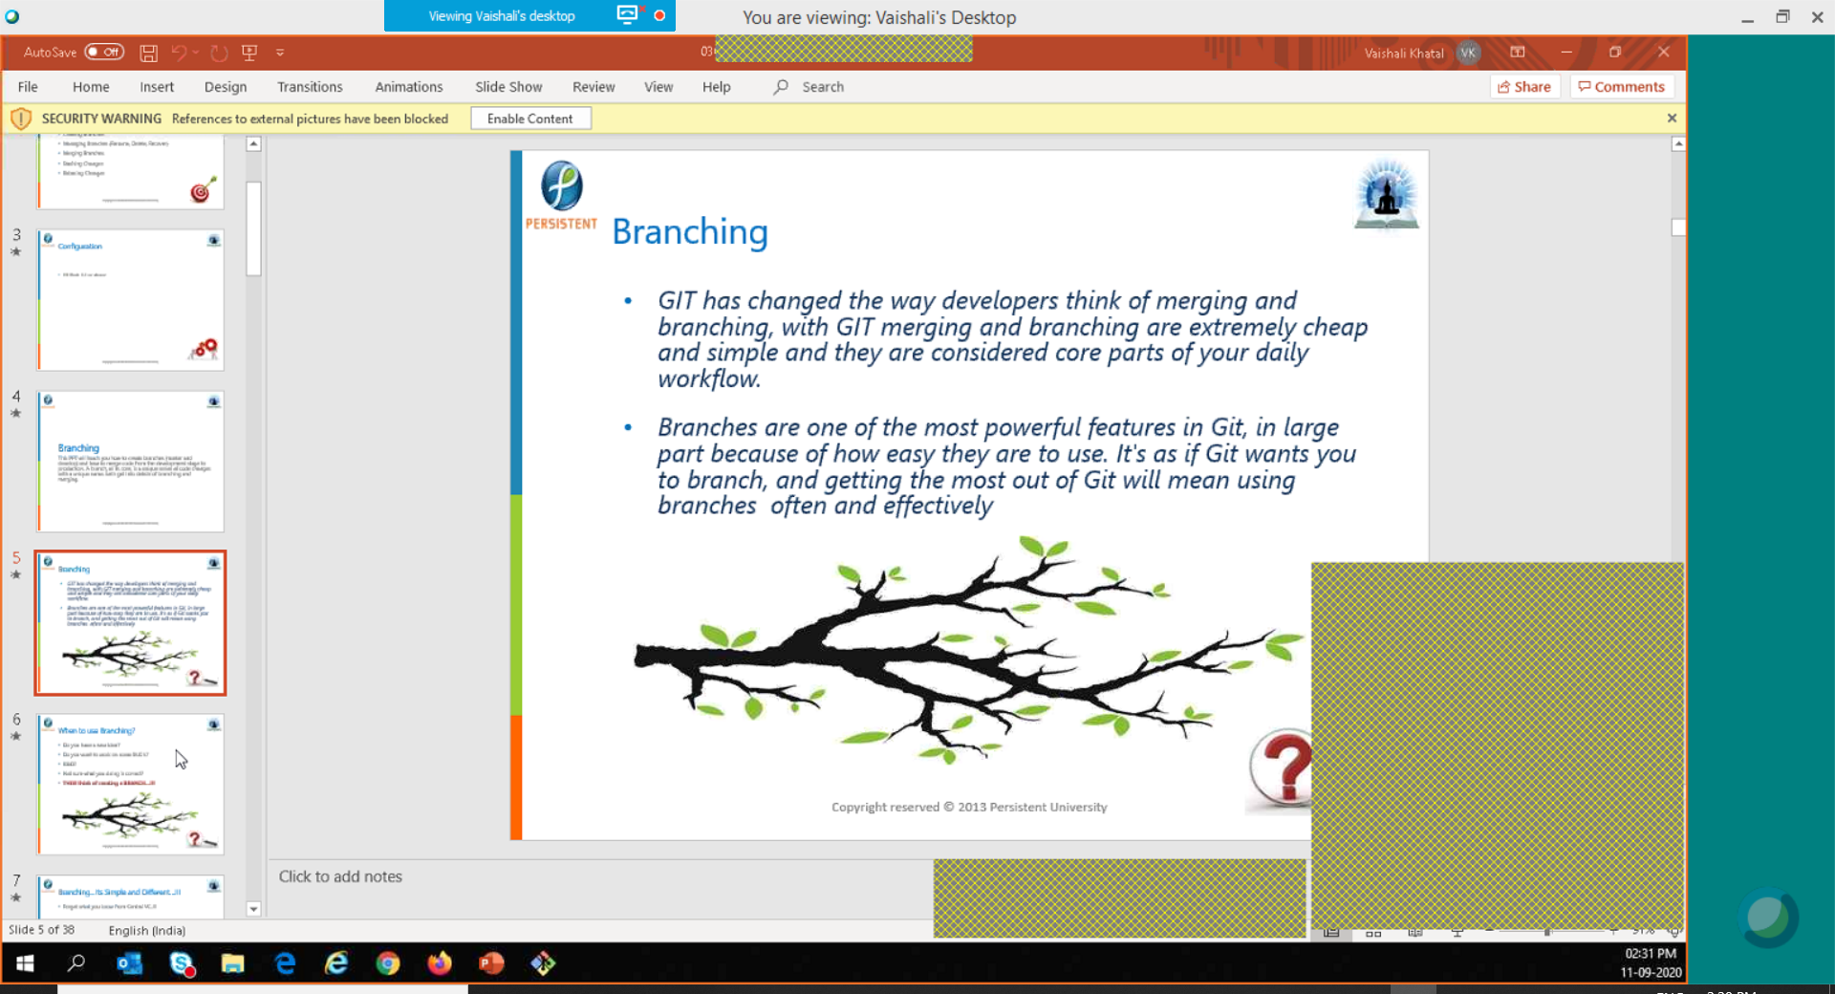

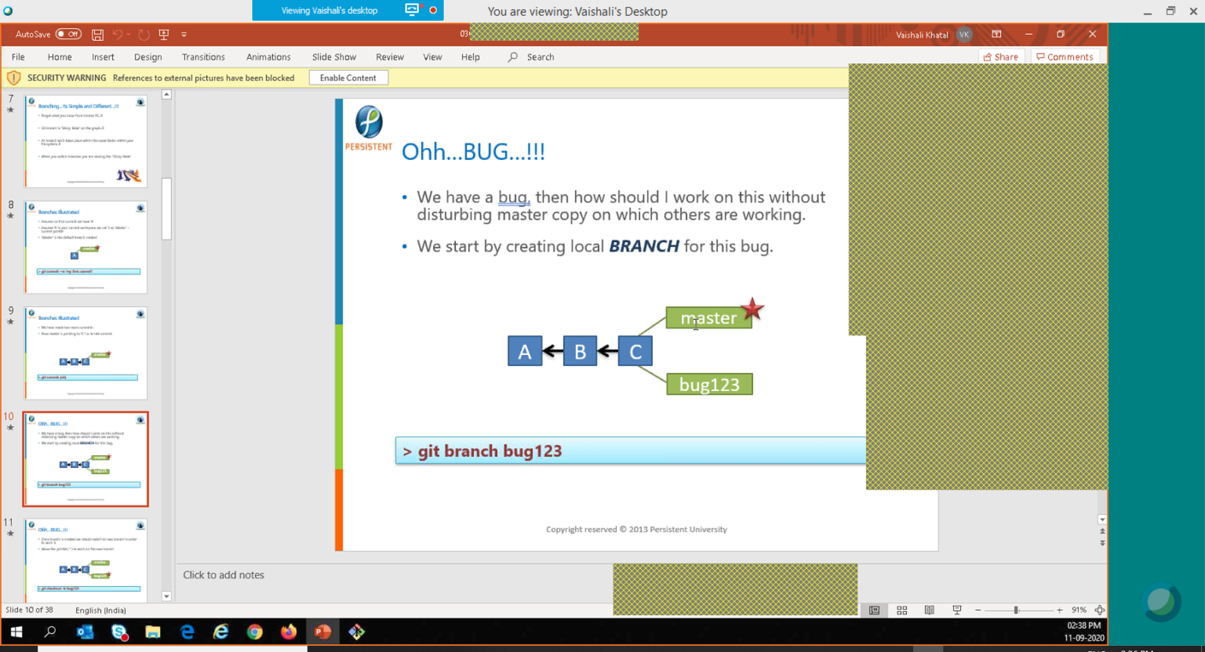

Here start is master head directory is points to master

To switch on bug 123 e have to use checkout

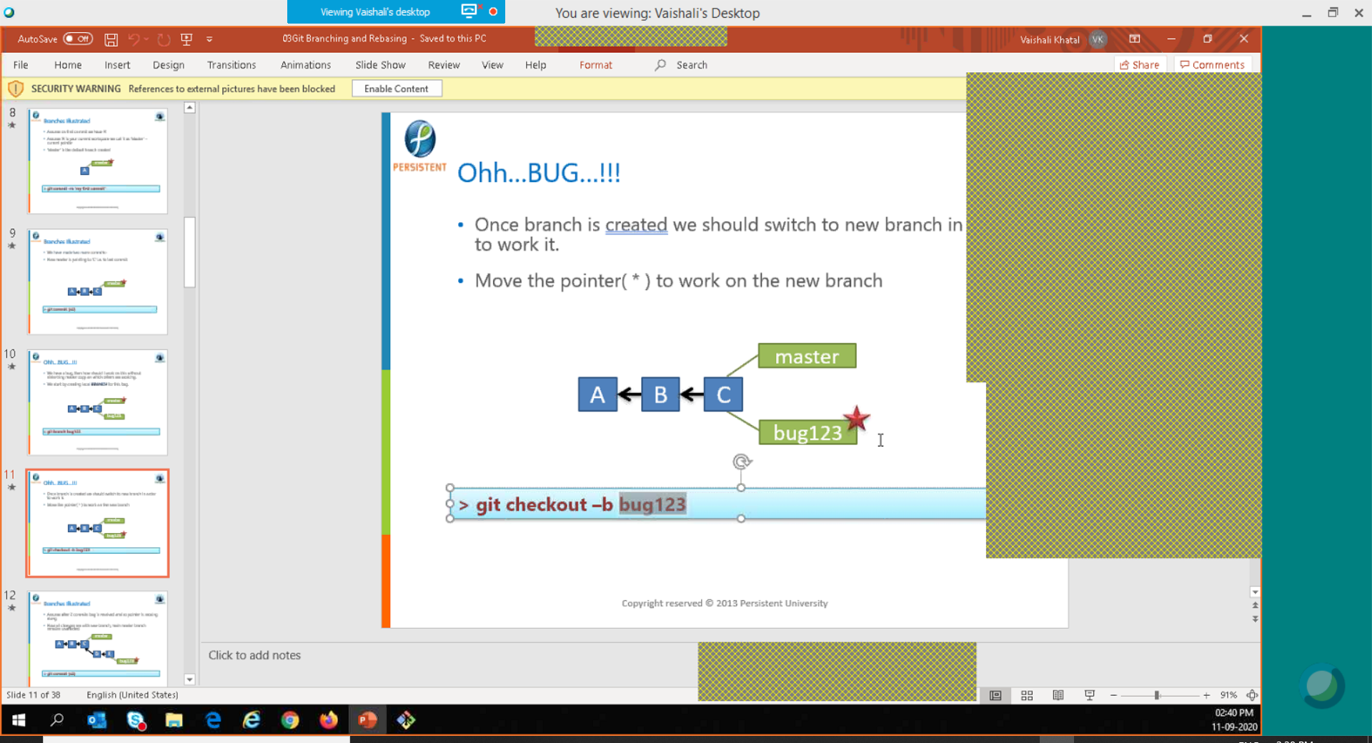

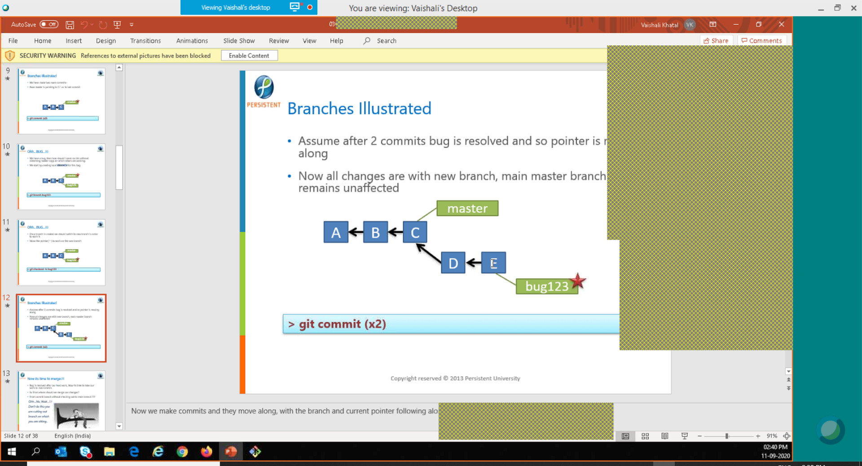

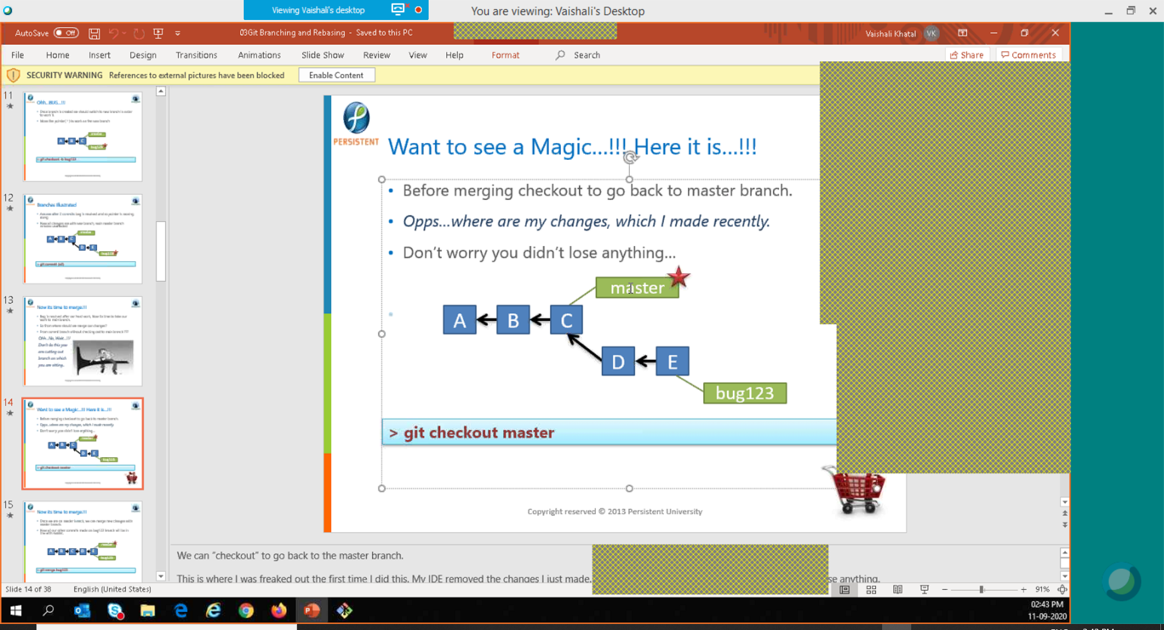

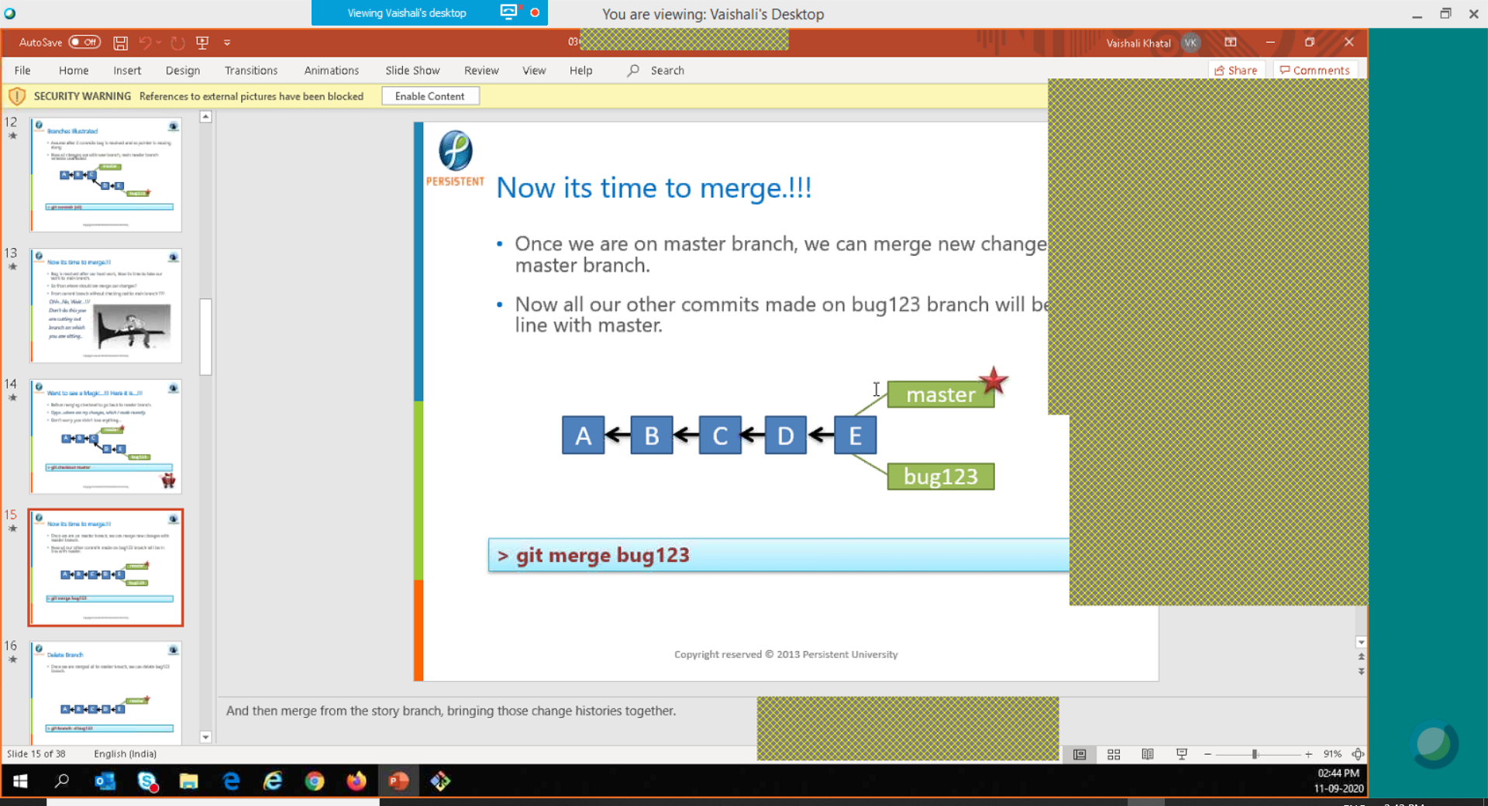

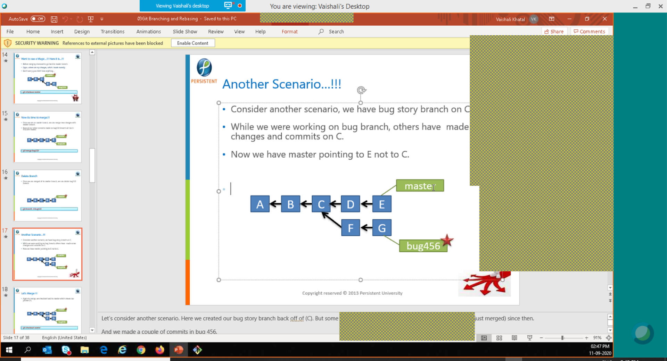

Github

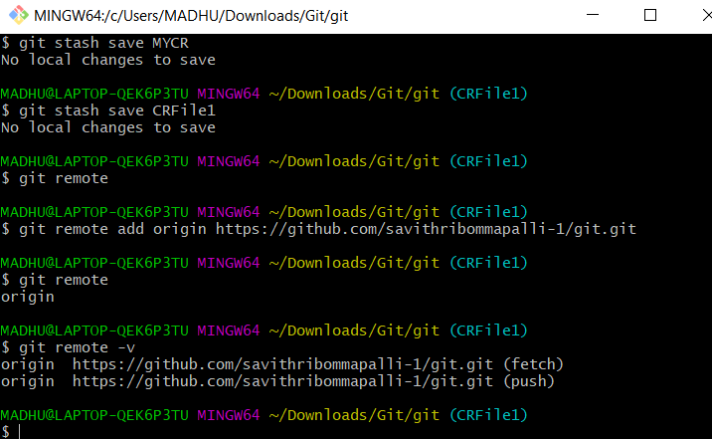

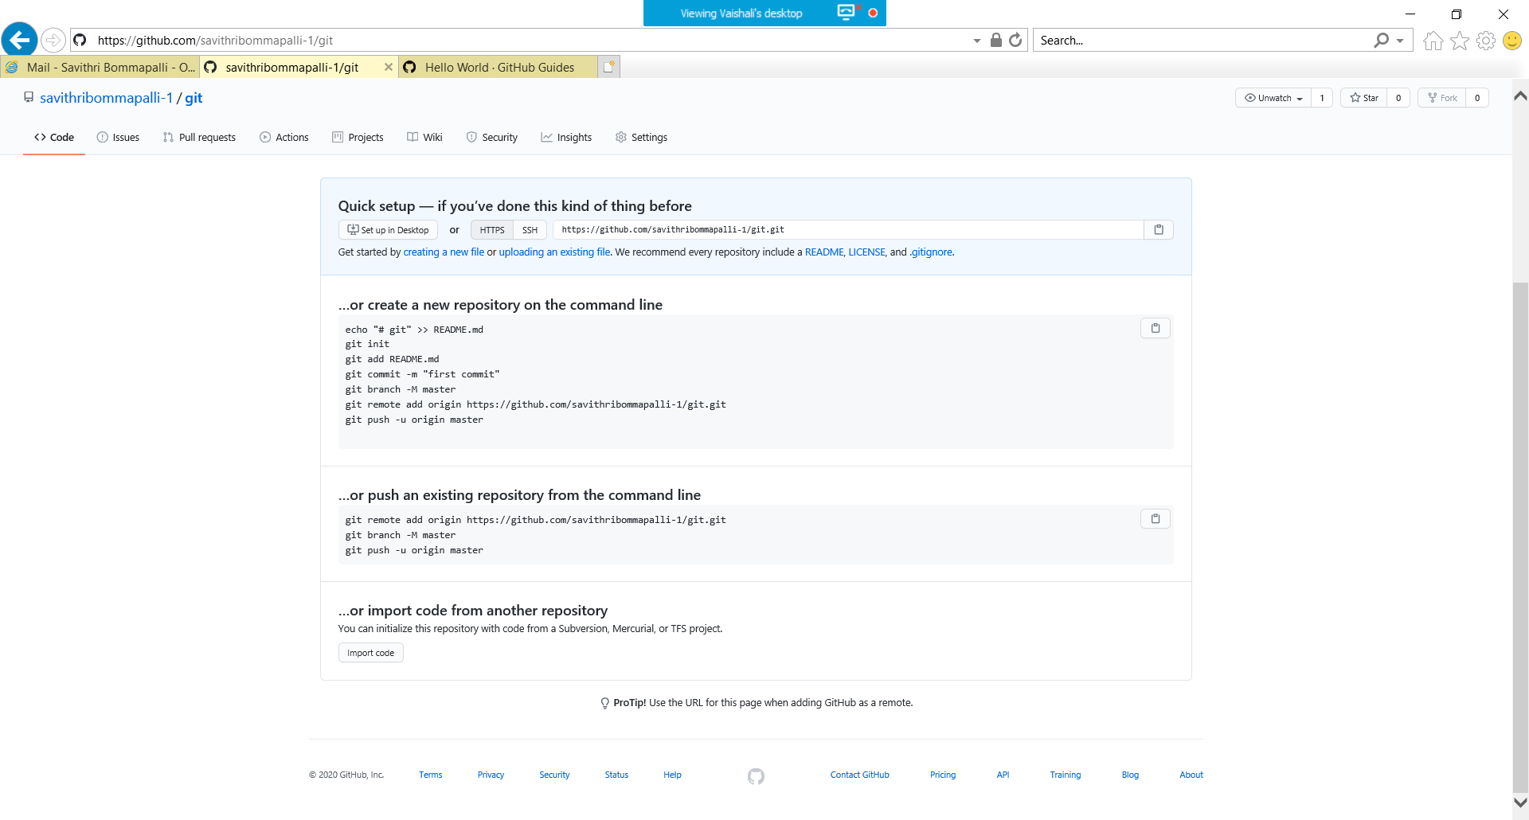

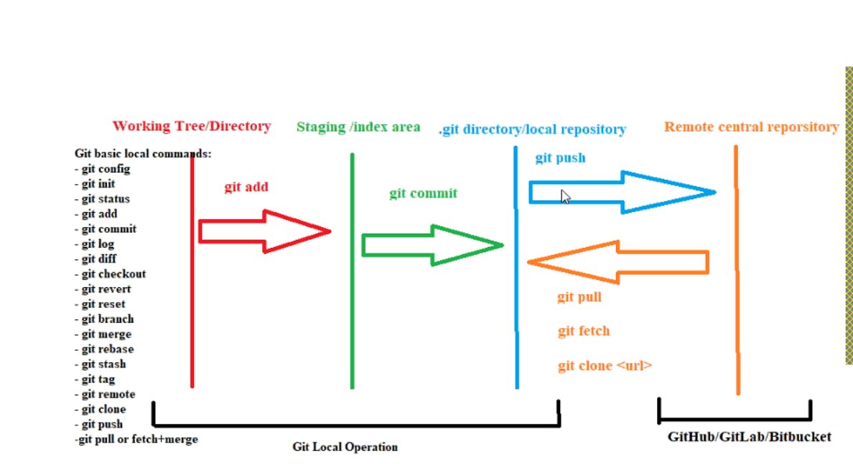

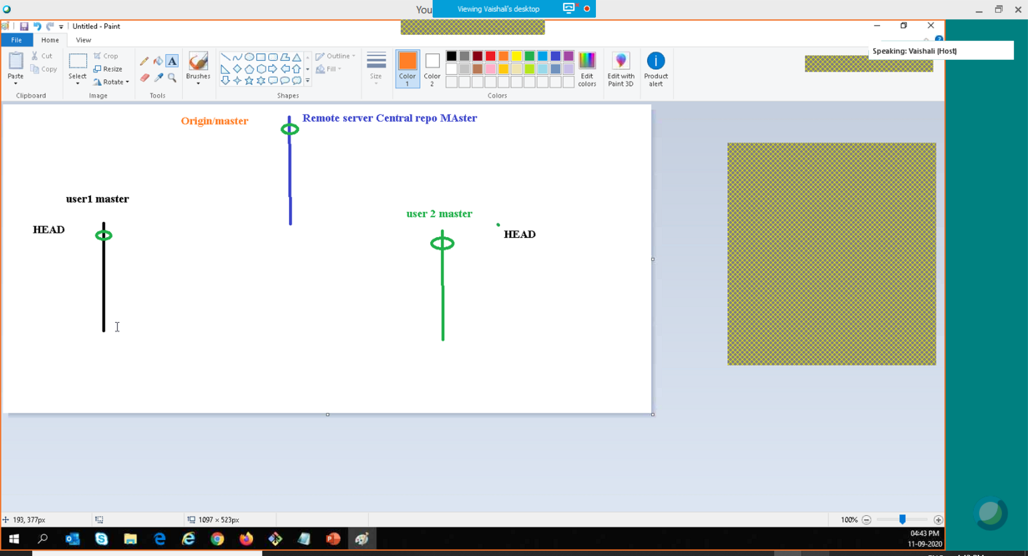

Git push -U origin

-u is update all details to roigin

Get clone repository url